Mc Donalds Meal Generator User Guide

Due Date: December 1st, 2020

Author: Brandon Polite

Purpose: Provide an instructional user guide for the McDonalds Meal Generator program

**Table of Contents**

*Content*  *Page*

----------------------------------------------------------------------------------------------------

1. Login *2*

1.1 - Login Screen & its functions

----------------------------------------------------------------------------------------------------

1. Register *3*

2.1 - Register Screen & its functions

----------------------------------------------------------------------------------------------------

1. Main Menu *4*

3.1 - Main Menu

----------------------------------------------------------------------------------------------------

1. Create Random Meal *5*

4.1 - Generate Meal Screen

4.2 - Generated Meal Result Screen *6*

4.3 - Favorite and Dislike controls *7*

----------------------------------------------------------------------------------------------------

1. Locations *8*

5.1 - Location Drop Down Menu

----------------------------------------------------------------------------------------------------

1. Check User Favorites *9*

6.1 - Favorites Screen

6.2 - Clear Favorites

6.3 - Remove Favorite

----------------------------------------------------------------------------------------------------

1. Logout *10*

7.1 - Logout Button

----------------------------------------------------------------------------------------------------

**Login**

**1.1 - Login Screen & its functions**

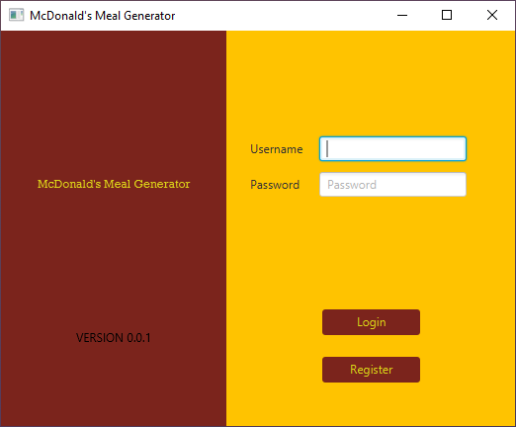

This section of the program allows you to login using your previously made credentials. Once logged in, you can access the main menu. Simply input your credentials into the username and password text box, and then click the login button. If you do not have previously made credentials, simply click register.

**Register**

**2.1 - Register Screen & its functions**

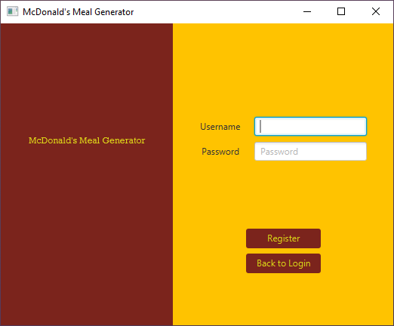

This section of the program allows you to create a user login by specifying a unique username and password combination. To access this section, simply click the register button, and to return to the login screen, hit the ‘Back to Login’ button.

**Main Menu**

**3.1 - Main Menu**

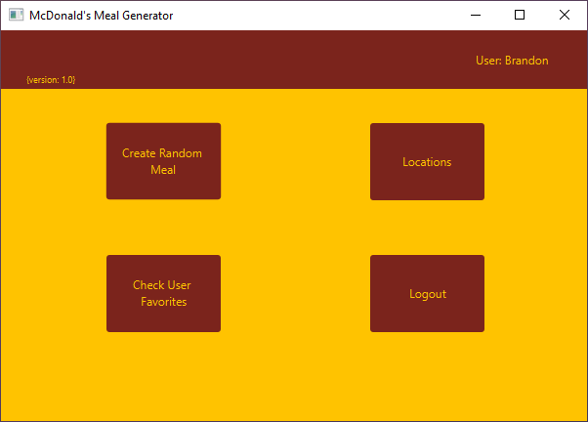

This section of the program allows you to access the core functions of the program, create random meals, access locations, and check user favorites. You can also log out of the program from here.

**Create Random Meal**

**4.1 - Generate Meal Screen**

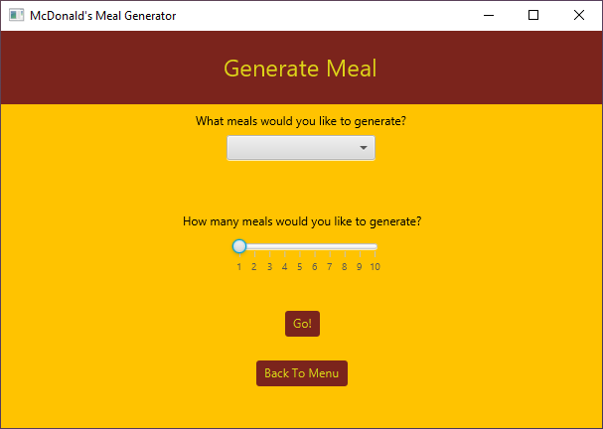

This section allows you to generate up to 10 meals. You can choose between breakfast and lunch using the dropdown menu and you can select the number of meals you wish to generate by dragging the slider to the desired number of meals. Once the desired specifications are achieved, simply hit ‘Go!’ to generate meals. You may also return to the menu by clicking ‘Back To Menu’

**4.2 - Generated Meal Result Screen**

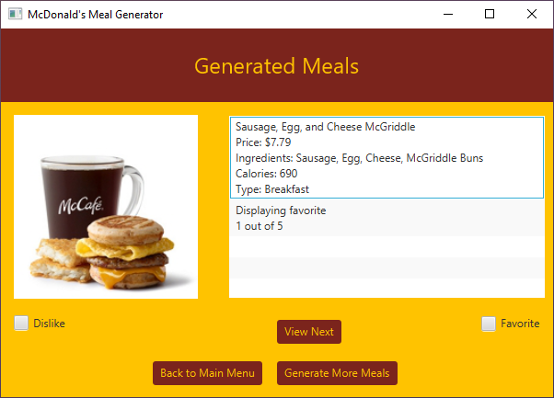

This screen allows you to see the meals information and name. The information tells the user the price of the meal, the total number of calories within the meal, the ingredients in the meal and the type of meal (breakfast or lunch). You can also either hit the ‘Generate More Meals’ button to return to the previous screen and generate more meals, or you can hit ‘Back to Main Menu’ to return to the main menu.

**4.3 - Favorite and Dislike controls**

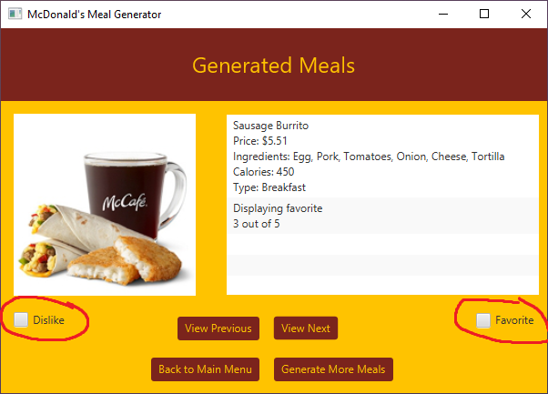

These check boxes allow you to either favorite or dislike a generated meal. Simply click on the favorite or dislike box to respectfully favorite or dislike the meal. You can check which meals have been favorited from the ‘Check User Favorites’ section of the program on the main menu.

**Locations**

**5.1 - Location Drop Down Menu**

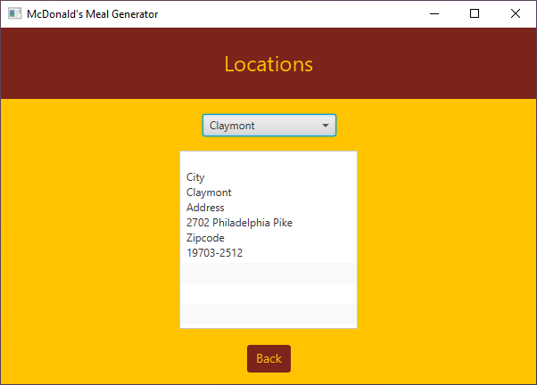

This menu will allow the user to select any location where there is a McDonalds and then display the location's city, address and zip code. To return to the main menu, click on the back button.

**Check User Favorites**

**6.1 - Favorites Screen**

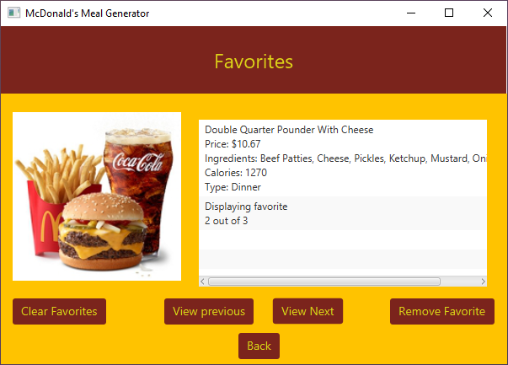

This screen displays meals that the user favorited in the meal generator. Here, they can view them whenever they want. This screen displays all the same information as the meal generator results screen, and also shows the user how many meals they have favorited. The user can use the view buttons to see either the previously favorite meal or the next favorite meal, in chronological order. Click the ‘Back’ button to return to the main menu.

**6.2 - Clear Favorites**

This button will remove all of the users favorites.

**6.3 Remove Favorite**

This button will remove the favorite currently displaying on the screen from the list of user favorites.

**Logout**

**7.1 - Logout**

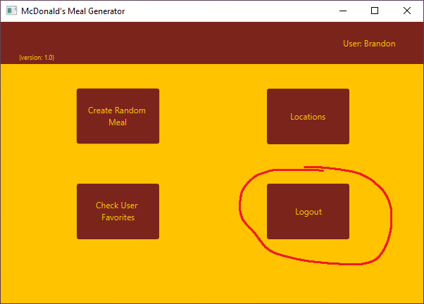

To log out of the program, simply click the ‘Logout’ button on the main menu. This will allow the next user to access all of their account’s favorites, while preventing the current users data to be accessed.